(Approx. 313 words)

Magic Sleeve
By Jasmine Blue D’Katz, Lake County Area Computer Enthusiasts
www.lcace.org
jj1450xl (at) yahoo.com

Got my new 12.9” iPad Pro last year, and even with the magic keyboard, it needed some extra protection when I travel with it. So, I decided to keep it protected with the Magic Sleeve. But I must say that I forgot I ordered it and was surprised when it arrived.

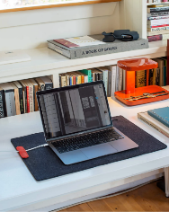
Magic Sleeve is a two-in-one desk pad and protective sleeve for my iPad Pro. The hidden magnet along the edge and the Merino wool felt sleeve allows seamless opening of the sleeve, which now becomes my desk pad. The Magic Sleeves come in various sizes to fit all iPads; the one I got for my 12.9” iPad Pro was 15-16”, and 16.75 x 23” unfolded. So, I ordered the charcoal sleeve, it is also available in natural grey.

I first ran across an ad for the Magic Sleeve and liked the two-in-one design and the fact that it was manufactured in the United States. Using 100% Merino wool from Australia was also a plus, and each sleeve is sewn by hand. Unfortunately, with the COVID-19 shutdown in March 2020, it took a while to get my order since Magic Sleeve’s Scott Nedrelow is a one-person business.

I like the feel of the pad, and it feels so good on my paws, but when I try to put my claws on it, I get yelled at. On the other hand, when I’m on the go, it wraps around the desk setup and opens new possibilities in how I’m organized when I travel.

At $99.00, it’s not cheap by any means, but I really appreciate the personal craftsmanship from the designer and creator. You get what you pay for, and I was very happy, and it was worth the wait.

I highly recommend this product.
magic sleeve – nedrelow

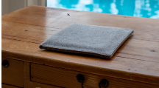
Nedrelow.com

